Vertex
# Source: AI Source: Provided by: [Data Path: Persons Table -> ID Column: 1, Name_En Column: Motasem Essam] -> From: [ChatGPT] on [7/25/2026]
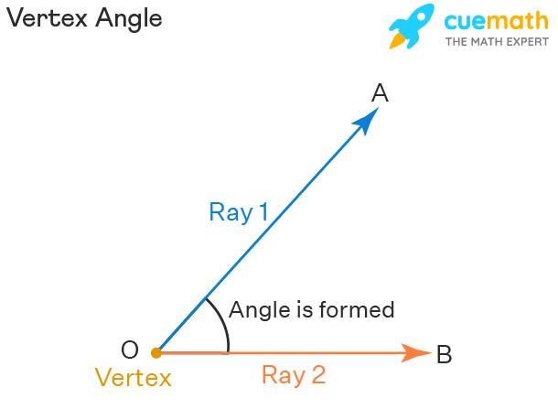
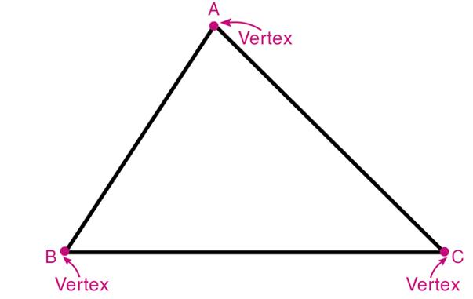
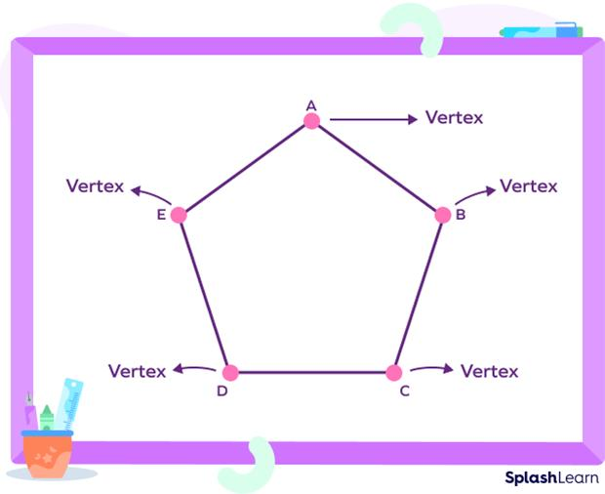
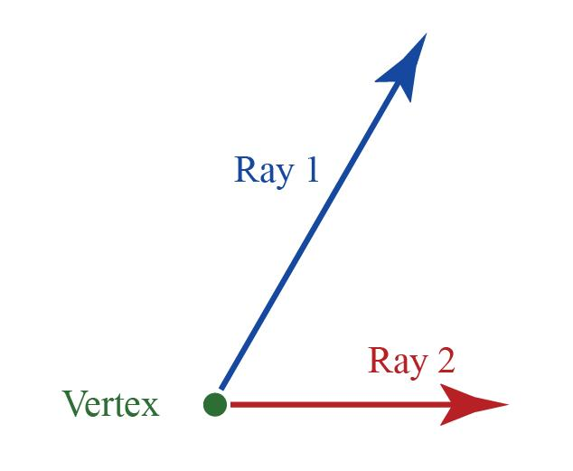
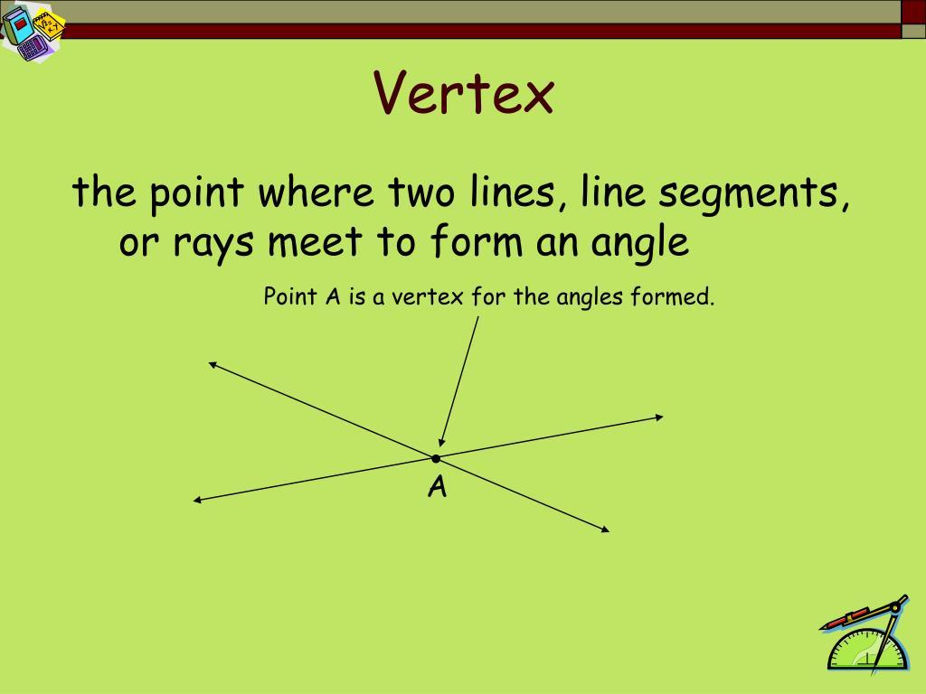
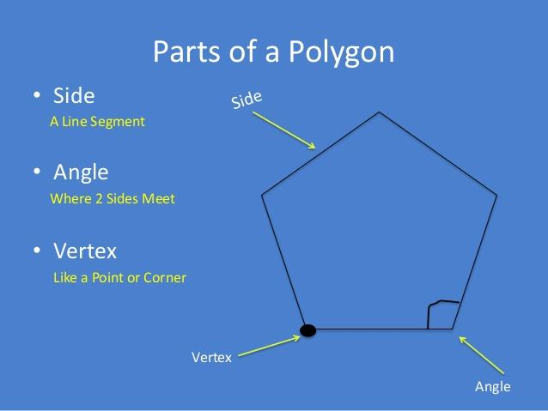

Definition
# Source: AI Source: Provided by: [Data Path: Persons Table -> ID Column: 1, Name_En Column: Motasem Essam] -> From: [ChatGPT] on [7/25/2026]
A Vertex is the common endpoint where two or more rays, line segments, or lines meet. In the context of rays, the vertex is the starting point from which the rays extend.
When two rays share the same endpoint, they form an angle, and the shared endpoint is called the vertex.

Characteristics
# Source: AI Source: Provided by: [Data Path: Persons Table -> ID Column: 1, Name_En Column: Motasem Essam] -> From: [ChatGPT] on [7/25/2026]
A vertex:
- Is a single point.
- Serves as the common endpoint of two or more rays.
- Is the point where an angle is formed.
- Does not have length, width, or thickness.
- Determines the location of an angle.

Illustration
# Source: AI Source: Provided by: [Data Path: Persons Table -> ID Column: 1, Name_En Column: Motasem Essam] -> From: [ChatGPT] on [7/25/2026]
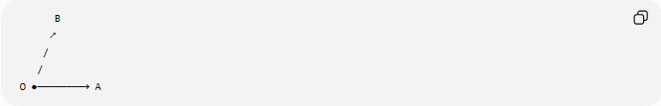
B
↗
/
/
O ●────────→ A
- $O$is the vertex.
- $\vec{OA}$and $\vec{OB}$are the rays.
- Together they form:
$$∠AOB$$

Mathematical Representation
# Source: AI Source: Provided by: [Data Path: Persons Table -> ID Column: 1, Name_En Column: Motasem Essam] -> From: [ChatGPT] on [7/25/2026]
If two rays
$$\vec{OA}$$
and
$$\vec{OB}$$
share endpoint
$$O$$
then:
- $O$is the vertex.
- The angle is written as:
$$∠AOB$$
The middle letter always represents the vertex.

Coordinate Geometry
# Source: AI Source: Provided by: [Data Path: Persons Table -> ID Column: 1, Name_En Column: Motasem Essam] -> From: [ChatGPT] on [7/25/2026]
Suppose:
$$O\left(0 , 0\right)$$
is the common endpoint.
Ray 1 passes through:
$$A\left(5 , 0\right)$$
Ray 2 passes through:
$$B\left(3 , 4\right)$$
The vertex is located at:
$$O\left(0 , 0\right)$$

Examples
# Source: AI Source: Provided by: [Data Path: Persons Table -> ID Column: 1, Name_En Column: Motasem Essam] -> From: [ChatGPT] on [7/25/2026]
Examples of vertices include:
- The corner of an angle.
- The hinge of an open door.
- The meeting point of clock hands.
- The corner of a polygon.
- The point where two roads meet.

Properties
# Source: AI Source: Provided by: [Data Path: Persons Table -> ID Column: 1, Name_En Column: Motasem Essam] -> From: [ChatGPT] on [7/25/2026]
A vertex:
- Is a point with no dimensions.
- Is common to all rays forming an angle.
- Remains fixed while the rays may rotate.
- May connect two or more rays.
- Identifies the position of an angle.

Applications
# Source: AI Source: Provided by: [Data Path: Persons Table -> ID Column: 1, Name_En Column: Motasem Essam] -> From: [ChatGPT] on [7/25/2026]
Vertices are used in:
- Plane Geometry
- Coordinate Geometry
- Trigonometry
- Engineering
- Architecture
- Construction
- CAD (Computer-Aided Design)
- Surveying
- Robotics
- Computer Graphics

Advantages
# Source: AI Source: Provided by: [Data Path: Persons Table -> ID Column: 1, Name_En Column: Motasem Essam] -> From: [ChatGPT] on [7/25/2026]
Studying vertices helps to:
- Identify angles.
- Describe geometric figures.
- Construct polygons.
- Analyze geometric relationships.
- Measure angular positions.

Limitations
# Source: AI Source: Provided by: [Data Path: Persons Table -> ID Column: 1, Name_En Column: Motasem Essam] -> From: [ChatGPT] on [7/25/2026]
A vertex:
- Is only a point.
- Has no measurable length or area.
- Requires rays or line segments to define an angle.

Comparison with Related Objects
# Source: AI Source: Provided by: [Data Path: Persons Table -> ID Column: 1, Name_En Column: Motasem Essam] -> From: [ChatGPT] on [7/25/2026]
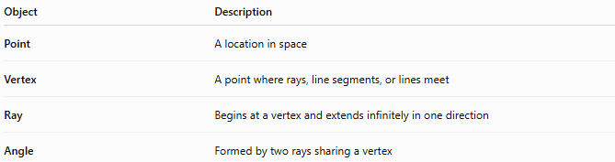
Object | Description
Point | A location in space
Vertex | A point where rays, line segments, or lines meet
Ray | Begins at a vertex and extends infinitely in one direction
Angle | Formed by two rays sharing a vertex

Key Points
# Source: AI Source: Provided by: [Data Path: Persons Table -> ID Column: 1, Name_En Column: Motasem Essam] -> From: [ChatGPT] on [7/25/2026]
- A Vertex is the common endpoint of two or more rays.
- It is the point where an angle is formed.
- In angle notation:
$$∠AOB$$
the middle letter O is always the vertex.
- A vertex has no dimensions.
- Vertices are fundamental in geometry, trigonometry, engineering, architecture, surveying, CAD, robotics, and computer graphics.

Conclusion
# Source: AI Source: Provided by: [Data Path: Persons Table -> ID Column: 1, Name_En Column: Motasem Essam] -> From: [ChatGPT] on [7/25/2026]
A Vertex is the common endpoint from which two or more rays extend, forming an angle or connecting geometric elements. Although it is simply a point with no length, width, or area, it plays a central role in defining the location and measure of angles and in connecting sides of geometric figures. Vertices are fundamental in plane geometry, coordinate geometry, trigonometry, engineering, architecture, construction, surveying, CAD, robotics, and computer graphics, where they are used to describe corners, intersections, rotations, and structural connections.

